Control flow Statements

- Conditional statement
- Looping statement
- Transfer statement

Conditional Statements
- If statement:
If(condition)
{
Statement 1;
Statement 2;
}
As seen above the way the way if condition work is
- If condition is true then the statement it will get executed.
- If condition false then the statement it will not get executed.
- Every condition at any point of time can have only one status either true or false.
- To generate Boolean, we need to comparison operators
- Comparison operators’ combination of equality and relational operator.
Ex: <, >, !=, ==, <=, >=
- The comparison operator has the ability to generate Boolean values hence these are used in condition.

Write java program to check if is greater than 100.
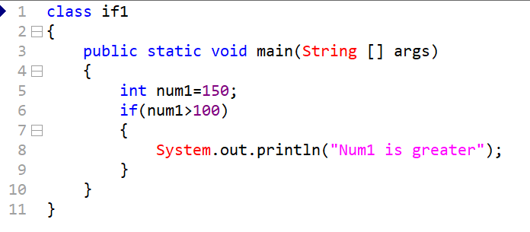
Syntax:
If(condition)
{
Statement;
}
else
{
Statement;
}

If the condition is true then the statement within if block will get executed. But if the condition is false the statement within else block will get executed.

Write java program to check if person is eligible for voting
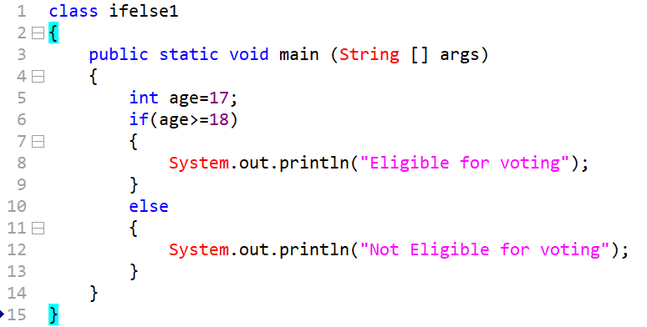

Write java program to check out of two numbers which one is greater.

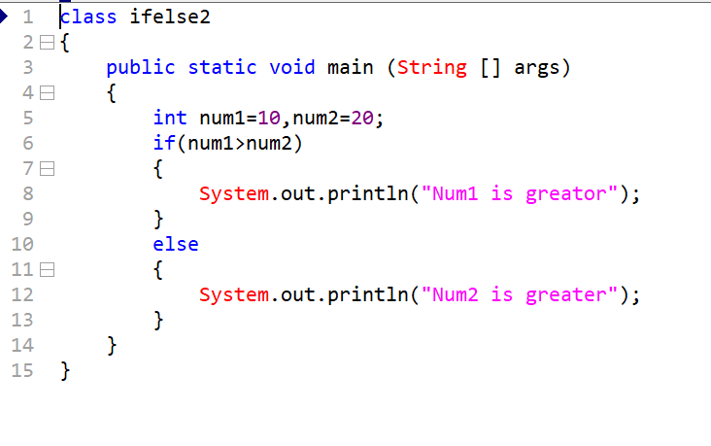

Write java program to check if person is eligible for marriage or not.
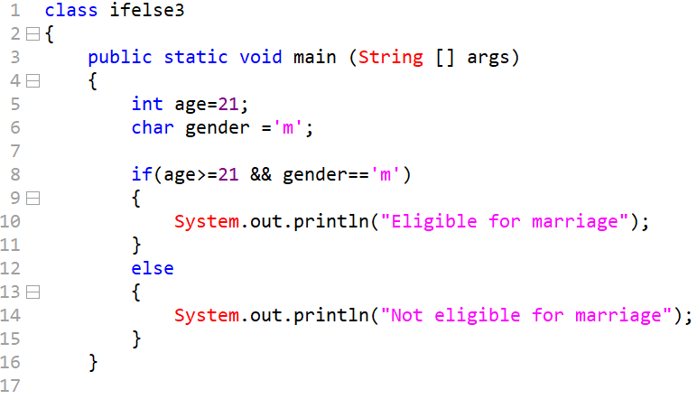

Truth table

Cond1 cond2 O/P
F F F
T F F
F T F
T T T

A Single equal two () is used for assignment or initialization where() operator is made for compare operations.
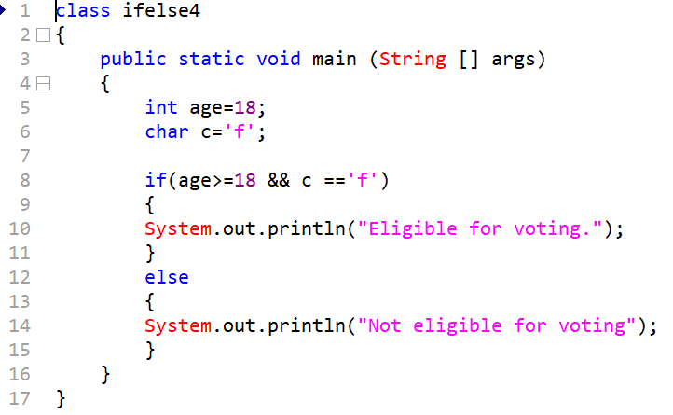

If else 3 and 4 combine
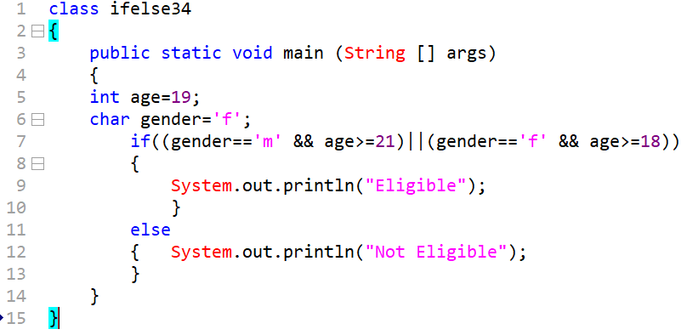

Write java program to check if program or student is eligible for IIT based on if the science or maths percentage is above 90%
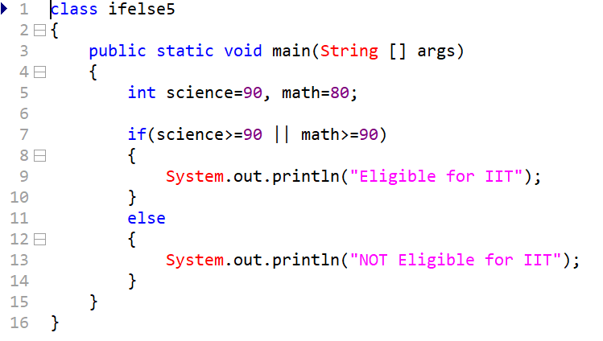

If else – if
Syntax:
If(condition)
{
Statement;
}
Else if(condition)
{ Statement; }
Else if(condition)
{ Statement; }
Else
{ Statement;
}

Write java program to check out of two number which one greatest and also check both are same
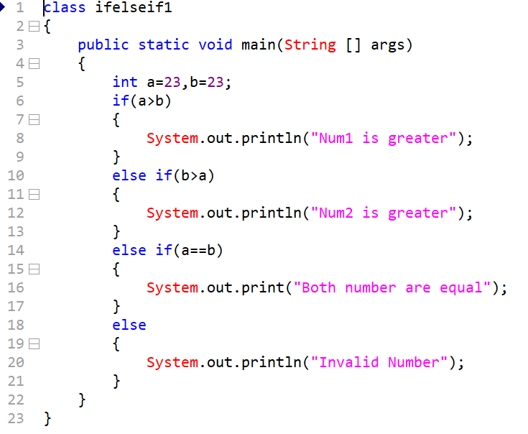
Write java program to simulate traffic signal
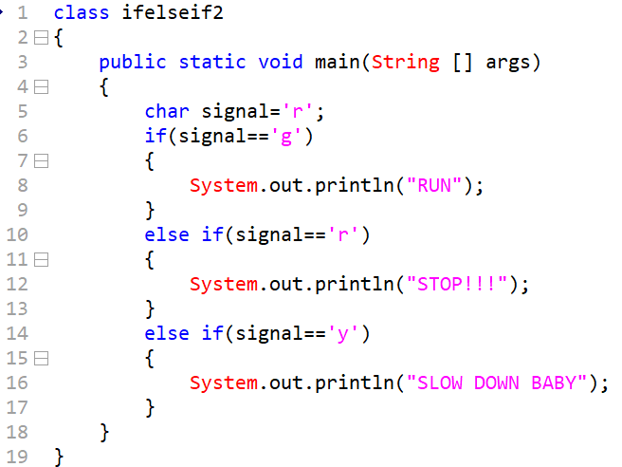
Write java program to simulate a banking domain
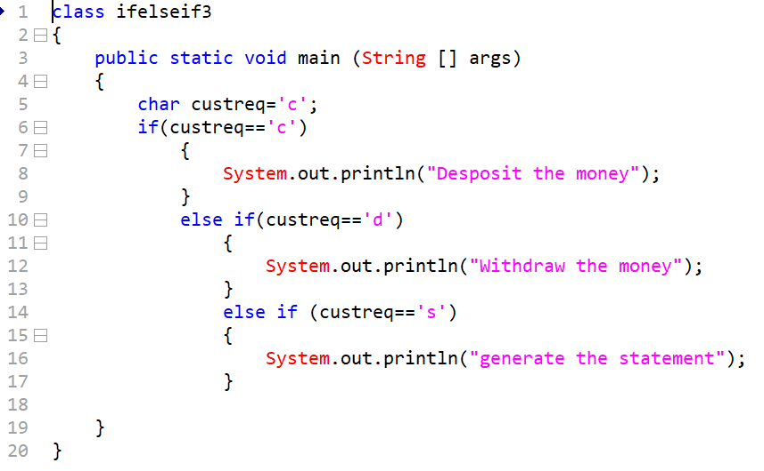

Nested if else
Syntax:
If(condition)
{
If(condition)
{ statement; }
Else
{ statement; }
}
Else
{
If(condition)
{ statement; }
Else
{ statement; }
}

Write java program to check whether product is available or not if it is available and quantity above file then purchase it.
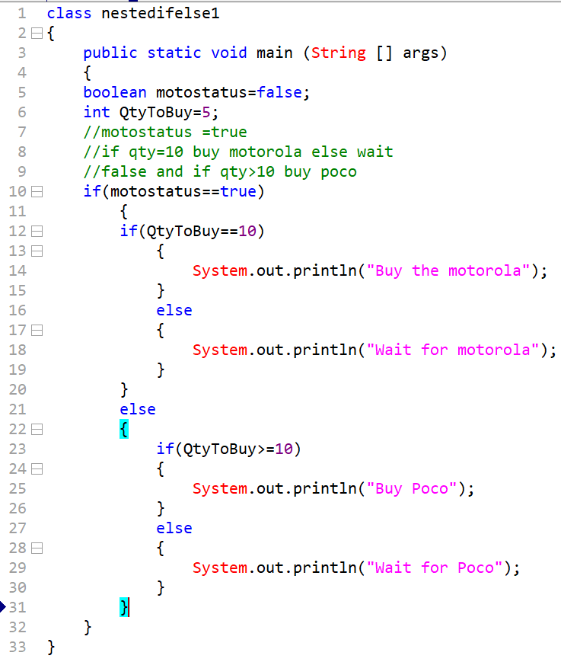

Switch statement
Syntax:
Switch(variable / argument / parameter)
{ case caselabel: statement;
Case caselabel: statement;
Default: statement;
}
Write a java program to implement switch statement
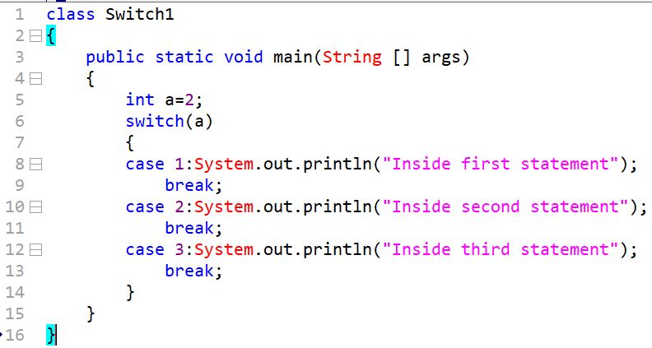
The switch statement works on a concept of case matching
In the switch statements it matches the arguments with the case label, whenever it matches it will execute the statements only of respective case.
Break statement: It is meant to break the control within the switch and hence it will move control outside the switch statement.

If the switch argument is not matching any of the case label, then by default it will match default case.
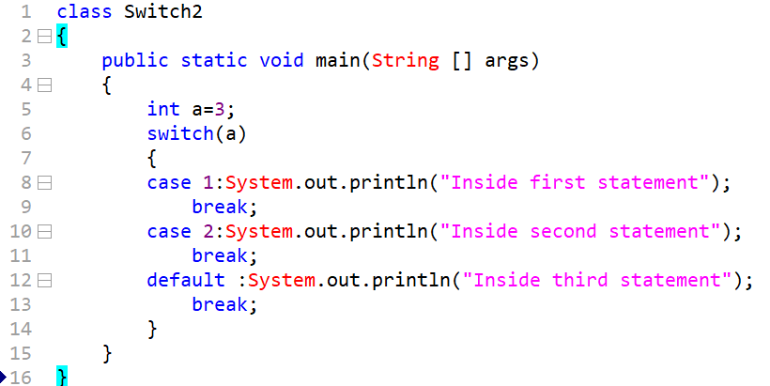

Break statements are not mandatory
Conclusion: while using switch statements always use break statement.
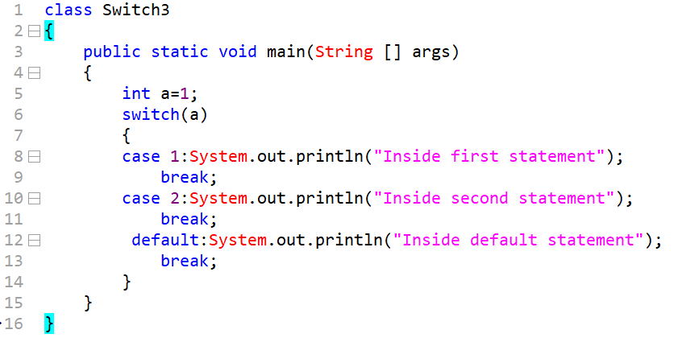

Cases are not mandatory with switch statement
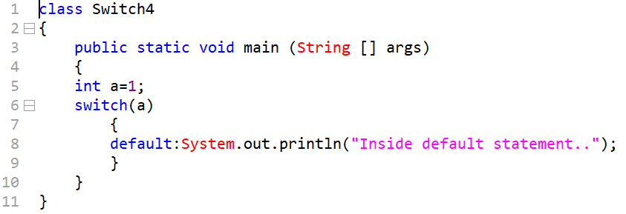
Default case is also not mandatory
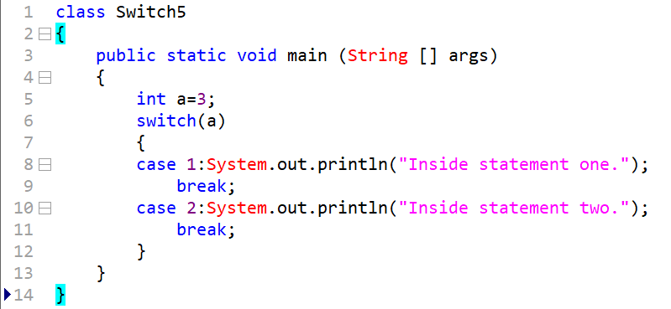
What is the output of following code class
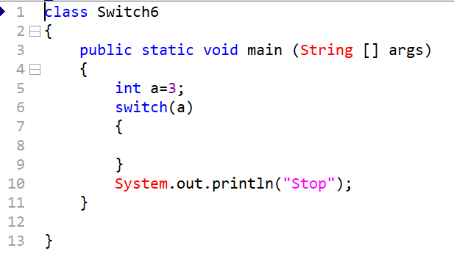
Conclusion: code will compile and execute because cases and default is not mandatory
Statement should be either part of cases or default else it will throw an error
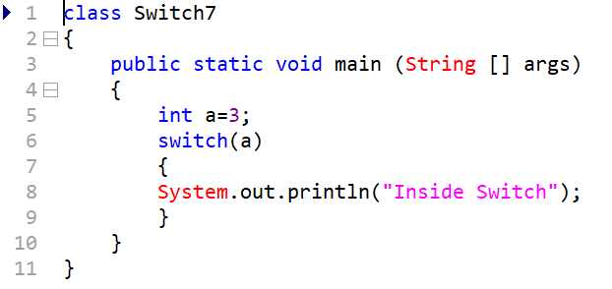
This code will throw an error.
What are valid and invalid argument in switch statement
Valid : int, short, byte, char, String
Invalid: float, long, double, Boolean
What is output of the following code?
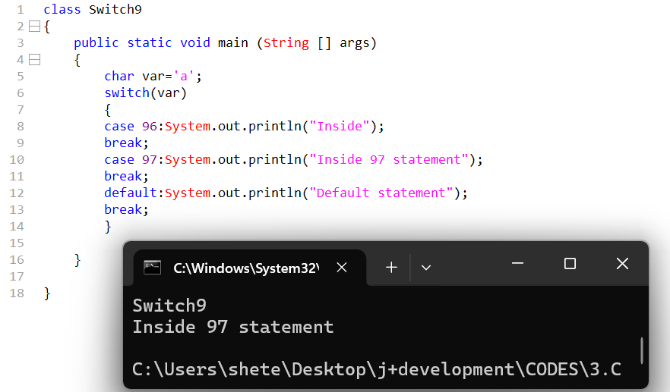
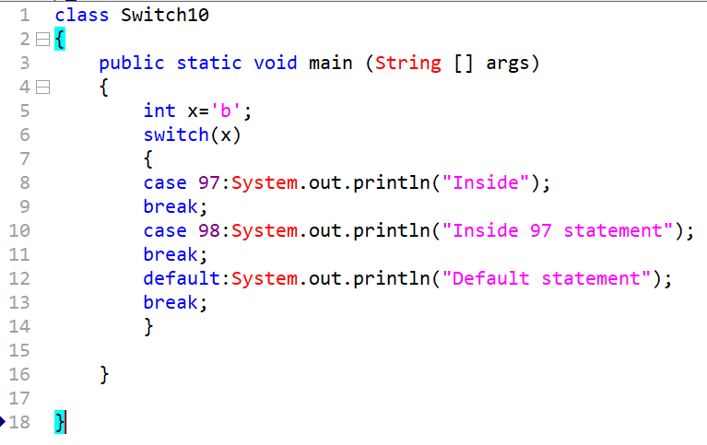
Duplicate case labels are not allowed in switch
The compiler throws an error for the below program because 99 with the help of Unicode character representation can be represented as character ‘c’ as well as character ‘c’ with the help of Unicode can be represented in the form of integer.

Based on the switch argument we can pass, the case label will be of same type else it will throw an error.
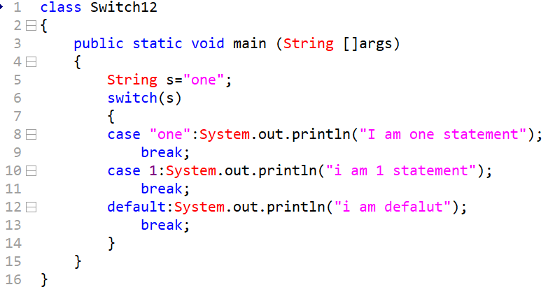
The case labels should be within the range based on the type of switch arguments
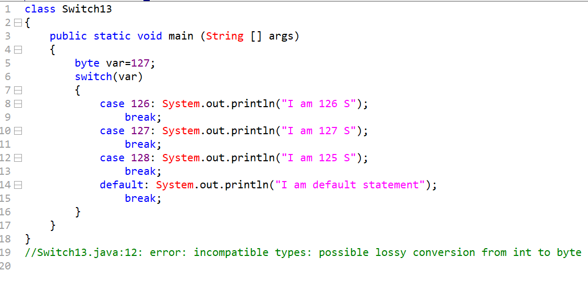

Constant
- To make variable behaviour as constant we need prefix keyword final before variable.
- A constant can be assigned only once if try to initialize or assign second time it will throw
//final

Looping statement
- Loops are used to execute defined statement for predefined number of types.
- The loop helps us to reuse the statement and also help reduce length of code which help consuming lesser memory which is increase speed application.
- There are mainly three type of loop
- For
- While
- Do while

For loop
For loop can be further categorized into three types
- For I
- Nested for
- For each>>> array collection

Syntax:
For (declaration/initialization, condition, increment/decrement)
{ statement;
Statement;
}

Increment and Decrement operators
- These operators are used to increment or decrement of a variable.
- These operators perform operation like increment or decrement with respect to value.
- These operators can further be categorized into two types
  - Pre: increment and decrement
  - Post: increment and decrement
- For pre increment operator it will first increment the value and only then it will perform the operation.
- With the help of post increment operator, we will first perform operation (print) and then it will perform increment.
//increment1
//decrement1

Write java program to print value from 1 to 3 using for loop
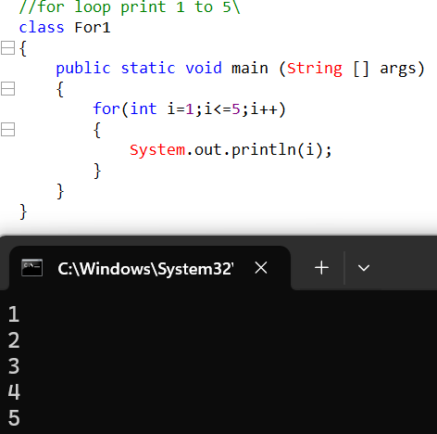
- Declaration and initialization only happen once.
- The condition is checked based on total number of iterations plus times (3+1)
- The increment and decrement will happens based on total number of iterations.
Write java program to check whether number 3 is present between one 1 to 5 numbers.
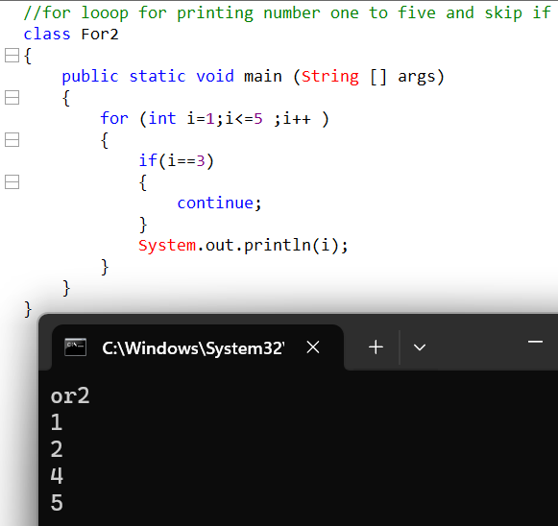

Write java program to display number from 1 to 3 in descending order.
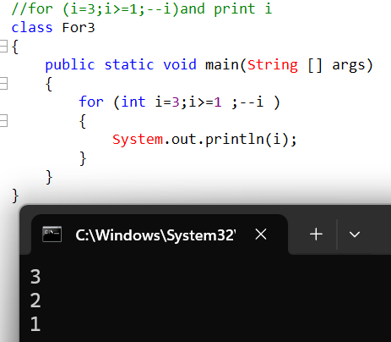
Declaration as well as initialization
Declaration and initialization is not mandatory within for statement.
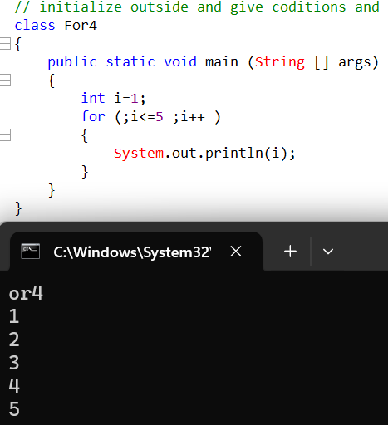

We can use single statement on multiple places of declaration as well as initialization.
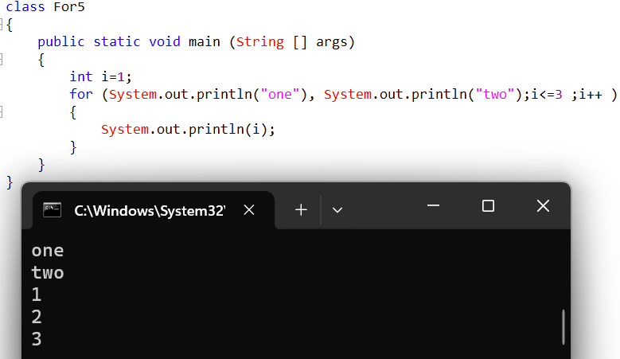
- If a variable is delared within the for loop it can be accessed only within the for loop but if a variable is declared within the main then it can be access within complete main area.
Conditions
- Condition is not mandatory
- If we do not set the condition then the compiler will set the default condition true
- Statements are now allowed in place of condition.
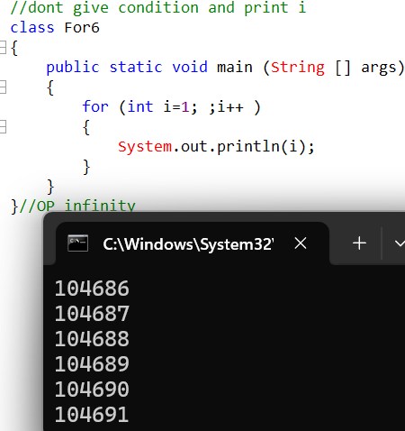
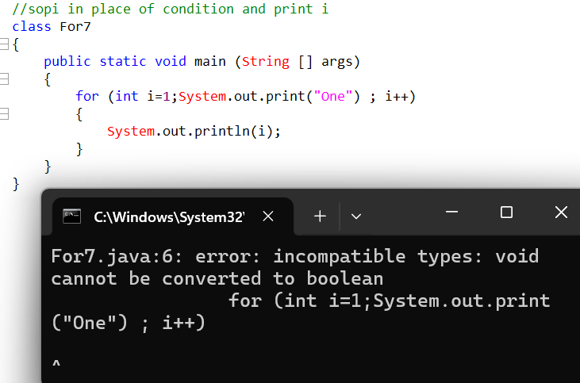
Write java program to swap values of two variables without using 3rd variable.
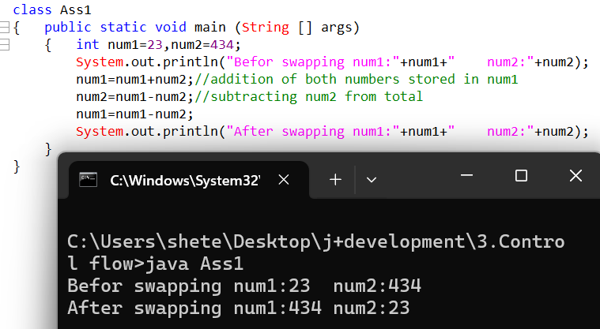

What is output of following code
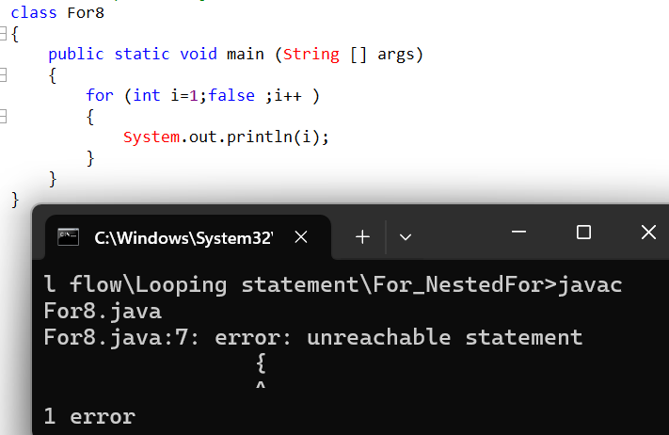
Output is error (unreachable statement) as a condition is false it will never reach the statement.
- Increment and decrement is not mandatory

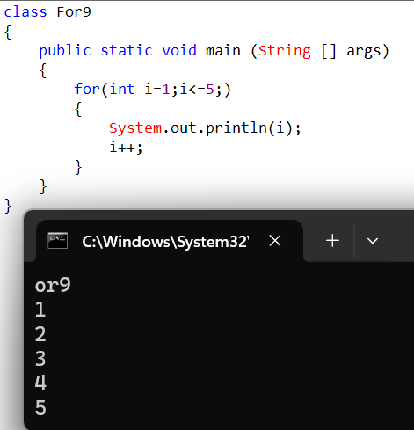

What is output of the following code
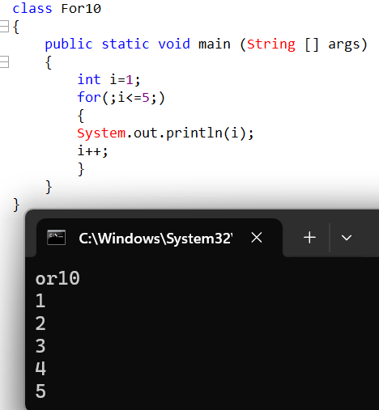
Single statements or multiple statements are allowed in place of increment and decrement.
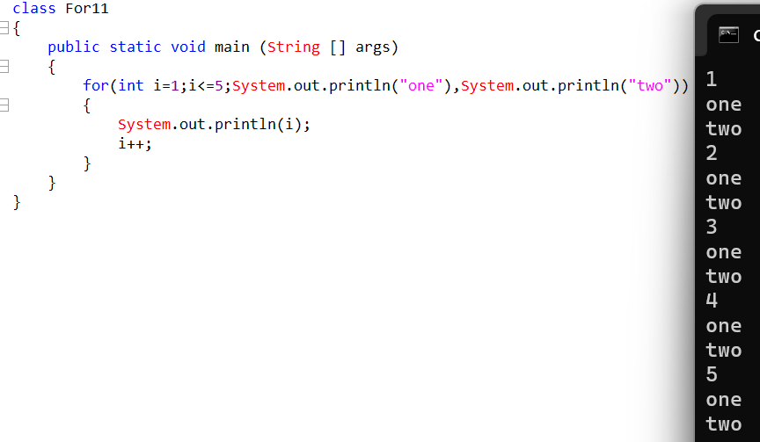
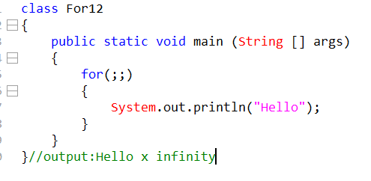

Nested For
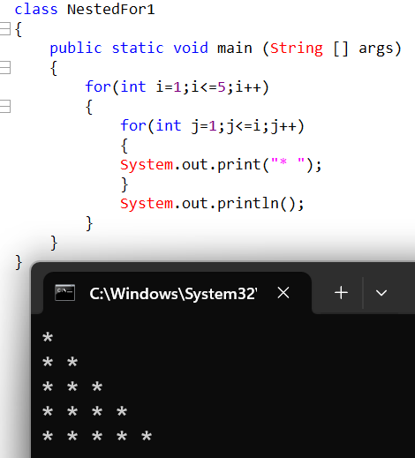
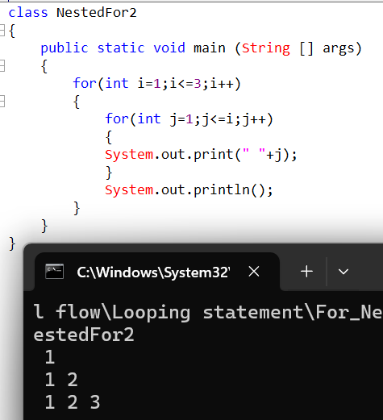
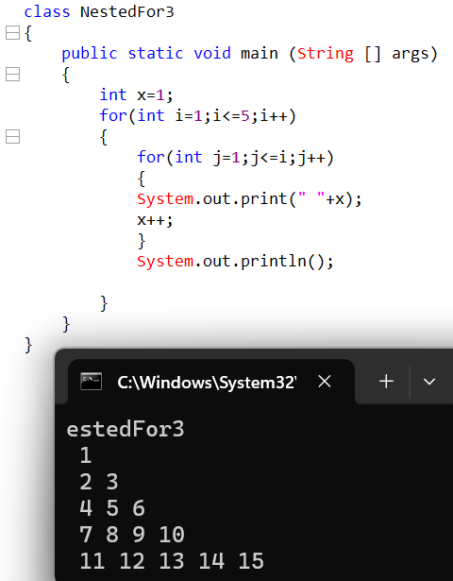

While
Syntax:
While(condition)
{ Statement1;
Statement2;
}
Write java program to print values from 1 to 5 using while loop.
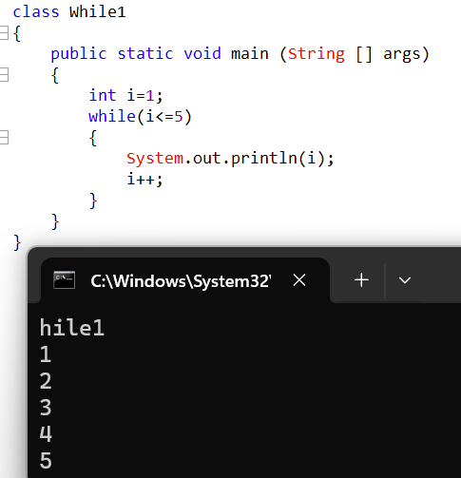

Write java program to iterate from 1 to 5 in ascending order and check if number 3 is present.
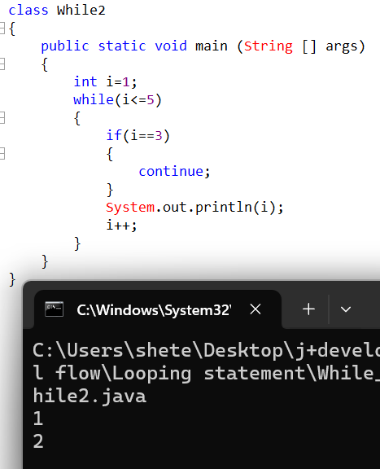
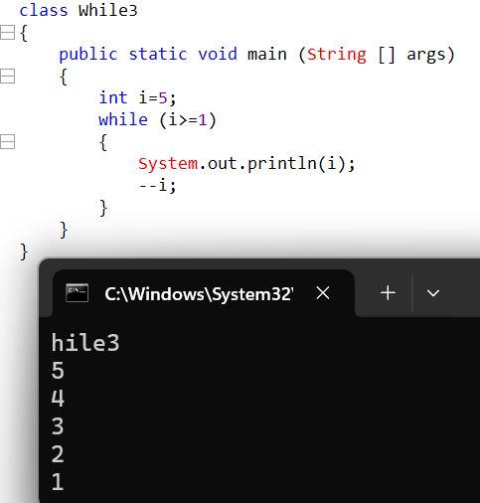

We cannot use statement in place of conditions
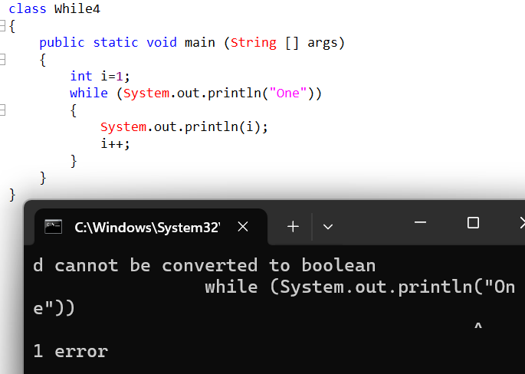

Write java program to print number from 1-5 in desending order using while loop

If we do not set any condition in while loop then the compiler will not set any default condition.
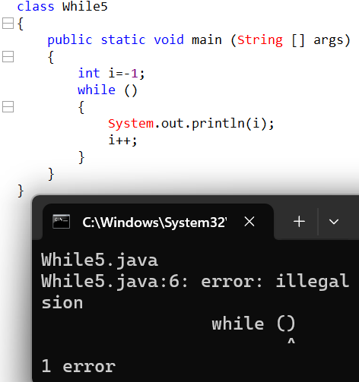
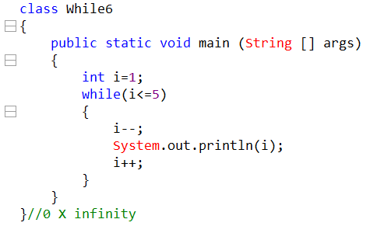
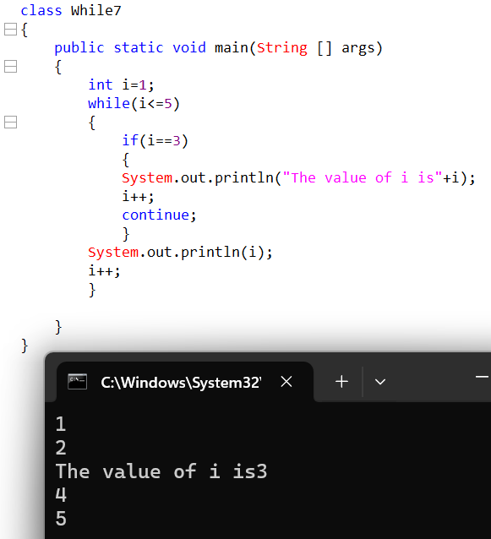
The for loop and while loop is meant to check the condition at the start hence such loops are called as entry-controlled loops.

Do-While loops
Syntax:
Do
{
Statement;
}
While(condition);
In do while loop condition is checked at the end hence such loops are called as exit control loops
Write java program to print numbers from 1 to 5 using do while loop
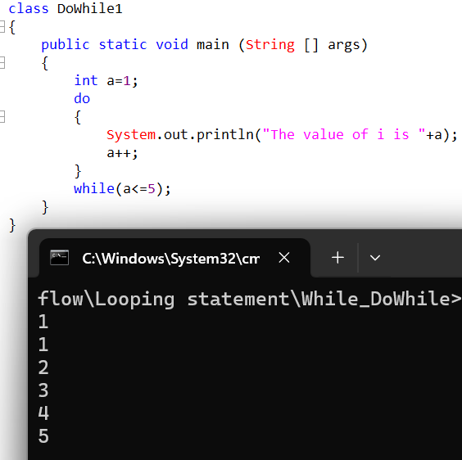
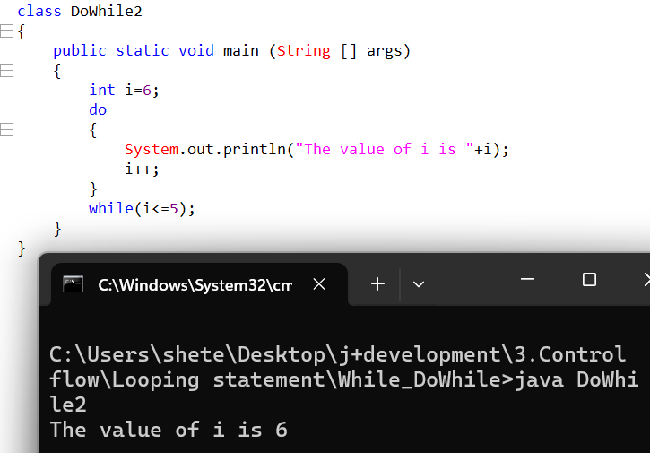
Regardless do while condition is true or false the statement within do while will at least get executed once
Write java program to print number from 1-5 in descending order.
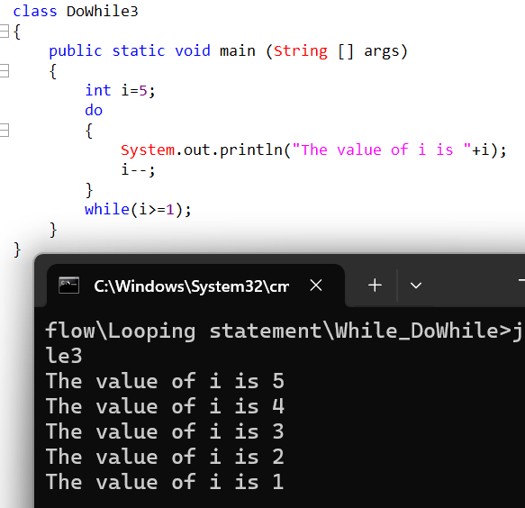
In the do while loop also if we do not set the condition the compiler will not set the condition which means condition is mandatory.
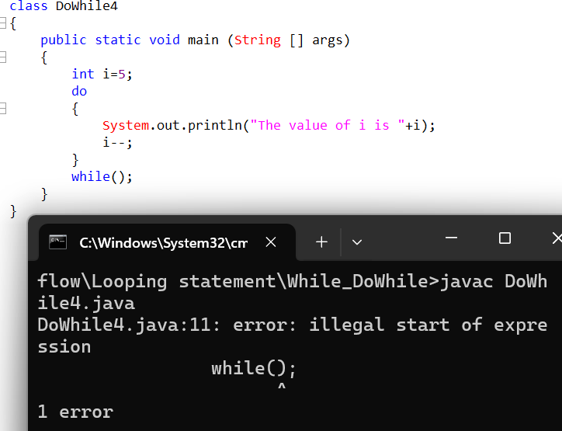
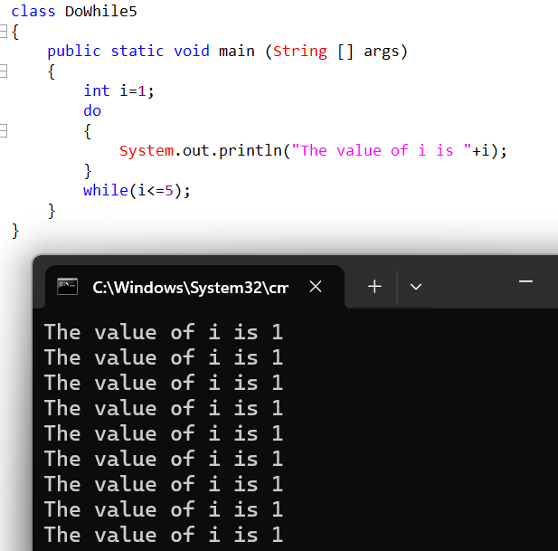
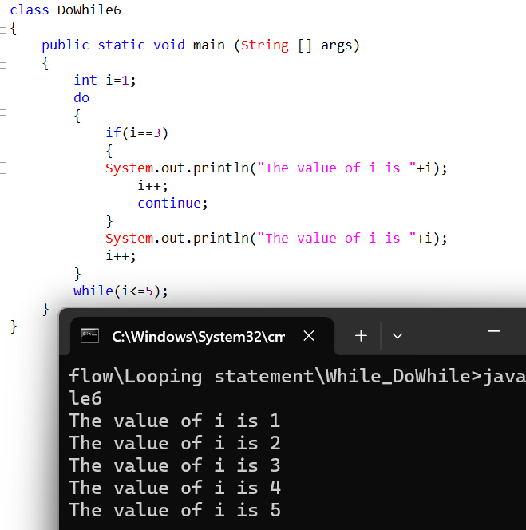

Transfer Statements

1.goto
These statements are use to move the control from one part of program to another part of program It is not consider as good coding practice but it is still supported by java.

2.return
Method

3.try-catch
Exception handling

4.break
it is meant to break the control either from switch or from loop it is not meant to break condition.
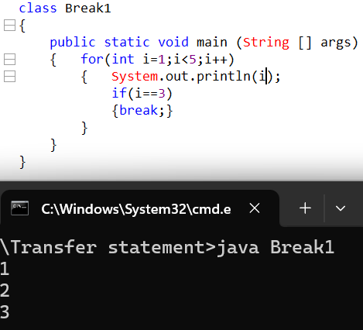

5.continue
The continue statement acts as a skip statement where, whenever the continue statement is encountered it will skip all the statements and move the control at the end of the loop.
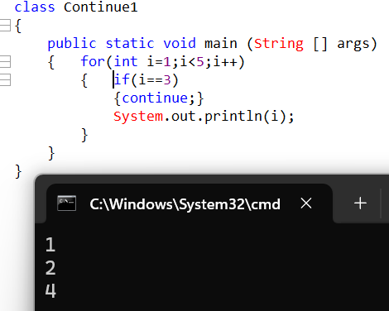
- When should we go for For loop and while loop
We use a for loop when the number of iterations is known beforehand. It is best suited for counter-controlled loops such as iterating over arrays, collections, or executing a block of code a fixed number of times.
for (int i = 0; i < 5; i++) {
System.out.println(i);
}
We use a while loop when the number of iterations is not known in advance and the loop execution depends on a condition. It is commonly used in scenarios like user input validation, reading data until a condition is met, or menu-driven programs.
Example: for printing list
- What does a break statement do?
- The break statement is used to immediately terminate the current loop or switch statement and transfer control to the next statement after it.
- When used inside a loop (for, while, do-while), it stops further iterations, even if the loop condition is still true.

- What will be the out put of the following code class


- What are valid and Invalid argument in switch statement
Valid : int, short, byte, char, String
Invalid: float, long, double, Boolean

- What will be the output of the following code

- What will happen if don’t set any condition in a for loop
If we do not set any condition in a for loop, the condition is treated as always true, so the loop becomes an infinite loop, unless we explicitly terminate it using break, return, or throw.

- Write java program to swap values of two variables without using 3rd variable.

- What are the entry-controlled loops.
- Entry-controlled loops are loops in which the condition is checked before entering the loop body.
If the condition is false initially, the loop body will not execute even once.
- In Java, for loop and while loop are entry-controlled loops

- What will happen if I don’t add break statement in switch
- If we do not add a break statement in a switch case, Java exhibits fall-through behavior.
- This means that once a matching case is found, all subsequent cases will execute, regardless of their case values, until a break or the end of the switch block is reached.
